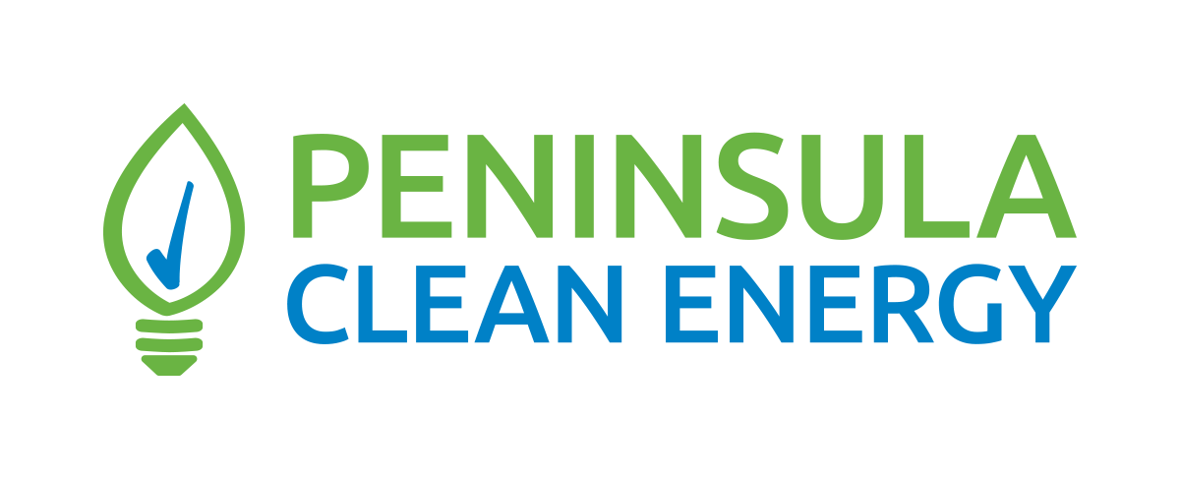
Related to Policy Number: 1

Board Adoption Date: February 25, 2021
Peninsula Clean Energy Authority 2021 Legislative Platform
Overview and Purpose
Peninsula Clean Energy Authority’s (PCE’s) Legislative Policy Platform (Platform) serves as a guide to the PCE Board of Directors and PCE staff in their advocacy efforts and engagement on policy matters of interest to PCE. The Platform allows both Board members and staff to pursue actions at the local, regional, state and federal legislative levels in a consistent manner and with the understanding that they are pursuing actions in the best interest of the organization and its mission, its member agencies, and its customers. The Platform also enables the organization to move swiftly to respond to issues before Legislature and Executive Branch agencies including California Public Utilities Commission, the California Energy Commission, California Independent System Operator, and the Air Resources Board so that PCE’s views can be heard on important matters in a timely fashion. The Platform also provides guidance to the Chief Executive Officer on support or oppose positions that should be taken on legislative matters identified by the staff legislative lead and the California Community Choice Association (CalCCA) Board of Directors.
- Governance and Authority
  - Oppose legislation that limits the local decision-making authority for CCAs, including rate-setting authority and procurement of energy and capacity to serve their customers.
  - Oppose legislation that limits PCE’s ability to effectively serve its customers.
  - Support legislation that makes it easier for other cities and counties to form a CCA, become members of PCE or other CCAs, and oppose legislation that restricts that ability.
- Decarbonization
  - Advocate for and support legislative efforts to accelerate decarbonization of the energy sector, transportation and the built environment
  - Advocate for and support legislative efforts to support and expand access to transportation and building electrification
  - Advocate for and support efforts to ensure flexibility in program design so that local data and local needs directly inform program offerings
  - Support state funding for electric vehicle infrastructure grant programs.
  - Support legislative efforts to incentivize the delivery of carbon-free energy on a 24-7 basis.
  - Advocate for and support legislative efforts to provide incentives to support underserved communities achieving decarbonization.
- IOU Charges and Exit Fees (Power Charge Indifference Adjustment (PCIA))
  - Support efforts that seek to eliminate exit fees including the PCIA or wind down exit fees within a reasonable time frame.
  - Support efforts to minimize the cost of the PCIA generally and minimize its impact on PCE’s rates.
  - Support CalCCA efforts to increase the transparency of IOU electricity contracts that provide the basis for PCIA charges.
  - Support legislation that would bring stability to the PCIA and/or provide new mechanisms for CCAs to securitize PCIA charges.
  - Oppose legislation that would increase or expand exit fees on CCA customers.
- Resource Adequacy
  - Support legislation by CalCCA to implement the recommendations from Working Group 3 via statute.
  - Oppose legislation that would supplant CCAs’ procurement authority for Resource Adequacy.
  - Support reform of the CPUC resource adequacy program to allow for stability in the resource adequacy value of existing resources.
  - Advocate for and support efforts to remove barriers to demand response, microgrids and behind the meter resources to provide Resource Adequacy.
- Environmental Justice
  - Support legislation that supports the ability of underserved communities in the PCE service territory to have affordable, reliable and clean energy.
  - Support legislation that strengthens the resilience of vulnerable communities to the impacts of climate change.
  - Support legislation that enables all communities, including emerging and historically marginalized communities in California, to participate in decarbonization efforts.
- Community Resilience
  - Advocate for and support funding for programs implemented by CCAs and their member jurisdictions to increase community resilience to wildfires, PSPS events and other potential service disruptions.
  - Support legislation that reduces barriers to microgrid development by CCAs.
  - Oppose legislation that would enable IOUs to be the only developer of microgrids.
  - Support legislation that increases development of community-level resources and distributed energy resources that increase resilience and reduce the need for new transmission and distribution infrastructure.
- Local Economic Development
  - Support legislation that is consistent with PCE’s commitment to a sustainable workforce.
  - Support legislation that enhances opportunities for CCAs to promote local economic development through locally designed programs that meet the unique needs of their member agencies, communities, and customers.
  - Support efforts to enhance development of local and regional sources of renewable energy.
  - Support legislation that enables CCAs to collaborate with their member jurisdictions on local energy resources and projects to advance environmental objectives.
  - Advocate for and support efforts to direct federal economic stimulus/recovery funding to CCAs to deliver local energy resources and projects, as appropriate.
- California Energy Market Structure
  - Oppose legislation that expands direct access or the ability or economic incentives for electric service providers to selectively recruit CCA or IOU customers.
  - Support legislation that would create renewable content and environmental standards for electric service providers to match the products offered by CCAs.
  - Support legislation that changes California’s market structures towards innovative models that reduce costs of energy service and supports the expansion of carbon-free resources.

