Reducing EVSE Installation Costs with Power Management

$5,300
estimated per port cost

Charging provided to all residents

$160,000+
estimated savings

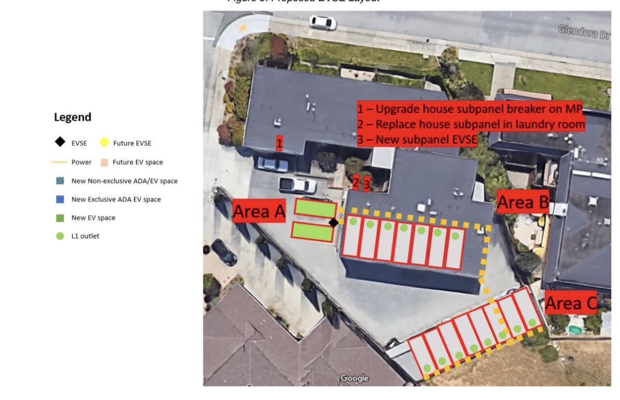
Background
San Mateo Apartments
- 17-unit apartment building in San Mateo County, built in 1975
- Not enough power in main panel to support Level 2 charging for all residents at full power (40 amps each)

Project Details
- Original request: 2 Level 2 dual-port stations (4 ports total)
- Accepted project: 1 Level 2 dual-port station with power management and 15 Level 1 outlets (17 ports total)
- Provides charging to all residents
- Per port cost: $5,300 (total cost estimate: $90,600)
- Installing 17 Level 2 ports would have cost at least $250,000+ (average $14,750+/port) and more if a new PG&E transformer was required

Strategies Utilized
- Level 1 Charging: Provides 40-50+ miles of range overnight to each resident, more than average daily commute distances and maximum need for most plug-in hybrid battery sizes
- Power Management: 2 Level 2 ports to be installed on a single 40-amp circuit and split power as needed to avoid exceeding circuit capacity, provides 200+ miles of range overnight when residents need additional charging

