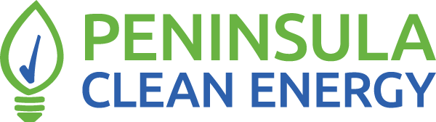

Request for Proposals
Aggregate Procurement of
Distributed Solar and Solar + Storage
for Public Facilities

Peninsula Clean Energy Authority, a California Joint Powers Authority, is seeking proposals from qualified vendors to engineer, procure, construct, and maintain solar and solar + storage projects for a portfolio of 15 public facilities in San Mateo County and Los Banos, CA.

Statement of Interest and Qualifications Due: July 15, 2022
Proposals Due: August 1, 2022
RFP Webinar: June 28, 2022 (Registration Link)

TABLE OF CONTENTS
1 ABOUT PENINSULA CLEAN ENERGY 4
2 RFP OVERVIEW 5
2.1 Procurement Model 5
2.2 Proposal Options 7
2.3 Minimum Proposer Requirements 7
3 RFP SCHEDULE 8
3.1 Questions & Answers: 10
4 DETAILED PROJECT DESCRIPTION AND SCOPE 10
4.1 Pilot Program Overview 10
4.2 Pilot Portfolio 11
4.3 Pricing and Customer Commitments 12
4.4 Project Packages 13
4.5 Project Development: Risk Mitigation Activities 13
4.6 Net Energy Metering (NEM) Changes 14
4.7 Pilot Nature / Flexibility and Cooperation 15
4.8 Safety 15
4.9 Scope of Work 15
5 PROPOSAL ELEMENTS 16
6 SUBMITTAL 20
6.1 Submission Format 20
6.2 Minimum Qualifications 21
6.3 Acknowledgment of RFP Terms 21
6.4 Checklist of Submission Materials 21
7 ADDITIONAL REQUIREMENTS 22
7.1 Insurance Requirements 22
8 REVIEW AND SELECTION PROCESS 23
9 AGREEMENT TERMS 24
10 SUPPLIER DIVERSITY 25
11 PENINSULA CLEAN ENERGY LEGAL OBLIGATIONS 26
12 GENERAL TERMS AND CONDITIONS 26

ABOUT PENINSULA CLEAN ENERGY
Peninsula Clean Energy Authority (PCEA), a community choice energy aggregator, is San Mateo County’s official electricity provider. Formed in February 2016, Peninsula Clean Energy is a joint powers authority, consisting of the County of San Mateo and all twenty of its towns and cities, as well as the City of Los Banos in Merced County. Peninsula Clean Energy provides cleaner and greener electricity, and at lower rates, than the incumbent investor-owned utility (IOU), Pacific Gas & Electric Company (PG&E). Peninsula Clean Energy plans for and secures commitments from a diverse portfolio of energy-generating resources to reliably serve the electric energy requirements of its customers over the near-, mid-, and long-term planning horizons. Peninsula Clean Energy’s programs include advancing the adoption of electric vehicles and transitioning building fossil fuel uses to low carbon electricity. For more information on Peninsula Clean Energy, please go to www.peninsulacleanenergy.com.
As part of its mission-driven, collaborative, not-for-profit, locally-focused roots, Peninsula Clean Energy is committed to the following:
Organizational Priorities
- Design a power portfolio that is sourced by 100% carbon-free energy by 2025 that aligns supply and consumer demand on a 24 x 7 basis
- Contribute to San Mateo County reaching the state’s goal to be 100% greenhouse gas-free by 2035 through electrification of transportation and buildings
Strategic Goals
- Secure sufficient, low-cost, clean sources of electricity that achieve Peninsula Clean Energy’s priorities while ensuring reliability and meeting regulatory mandates
- Strongly advocate for public policies that support Peninsula Clean Energy’s Organizational Priorities
- Implement robust energy programs that reduce greenhouse gas emissions, align supply and demand, and provide benefits to community stakeholder groups
- Develop a strong brand reputation that drives participation in Peninsula Clean Energy’s programs while ensuring customer satisfaction
- Employ sound fiscal strategies to promote long-term organizational sustainability
- Ensure organizational excellence by adhering to sustainable business practices and fostering a workplace culture of innovation, diversity, transparency, and integrity

RFP OVERVIEW
Peninsula Clean Energy Authority (PCEA) issues this Request for Proposals (RFP) to seek proposals from qualified companies to procure, install, commission, and maintain solar photovoltaic (solar) and solar photovoltaic paired with battery energy storage systems (solar + storage) for a portfolio of 15 public facilities in San Mateo County and Los Banos, California.
PCEA, in conjunction with a solar engineering and design firm, has undertaken significant project development activities to date, including:
- Outreach to local government about benefits of solar and storage
- Conducting site evaluations and developing system designs
- Creating site plans and single line diagrams
- Estimating solar production using PVsyst
- Conducting structural engineering reviews
- Building support for projects among facility and public works staff
- Obtaining city council approvals for projects
We are now moving to the next phase of the project, securing a vendor for the procurement, installation, and maintenance of the designed solar and solar + storage systems.

Procurement Model
PCEA is exploring a new model whereby it will offer a Power Purchase Agreement (PPA) directly to customers for the energy produced by the systems over the PPA term. The diagram below illustrates the procurement options being explored under this model.
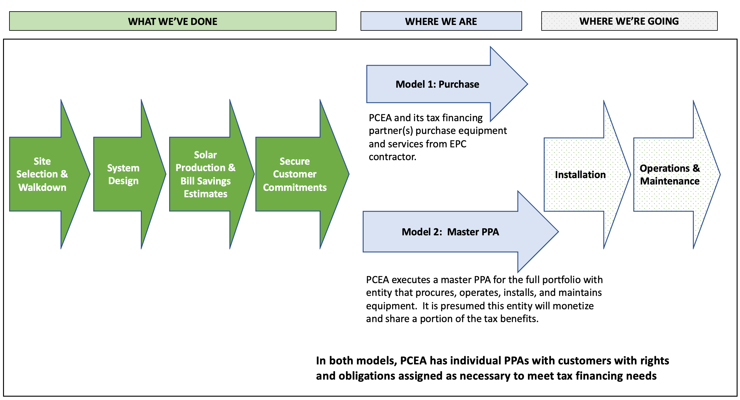
For further clarity on the anticipated deal structures behind these two models, we anticipate adopting one of the two following models:
Model 1 – Purchase: PCEA, through this solicitation, contracts an Engineering, Procurement, and Construction (EPC) to procure, install, and commission equipment as well as provide ongoing maintenance and monitoring of equipment, including conducting any required warranty and repair work. In this model, PCEA obtains tax financing separately and equipment and services are purchased from the EPC via specified milestones.
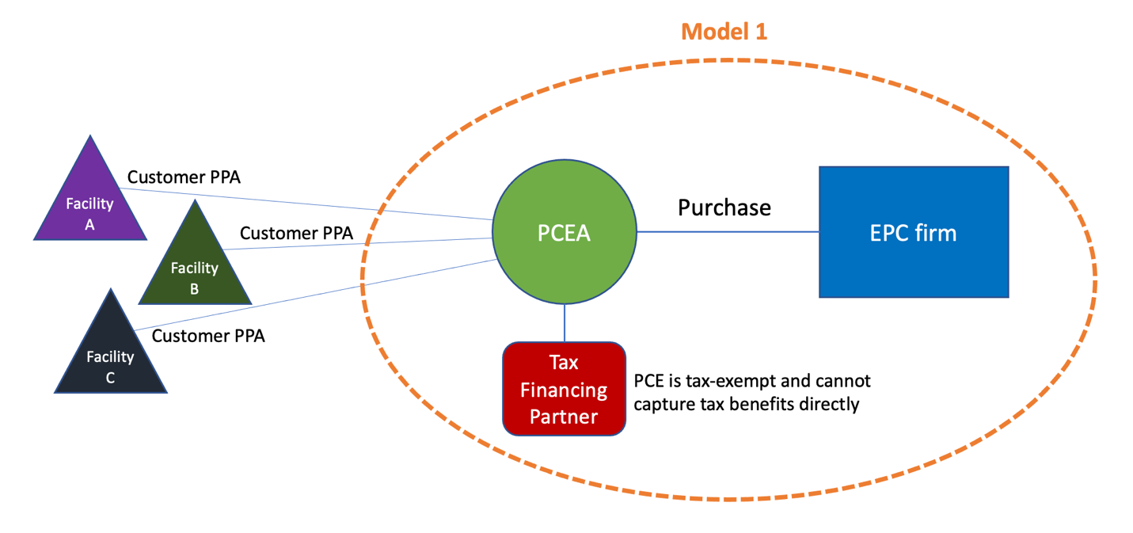
Model 2 – Master PPA: Peninsula Clean Energy contracts with a Bundled PPA Provider (PPA provider + EPC + Tax Equity provider) for a Master PPA for the aggregate portfolio. In this model, Peninsula Clean Energy is the buyer of a master PPA from the bundled provider for the procurement, installation, and maintenance of systems, and the provider of individual PPAs to customers for the energy dispatched by those systems over the PPA term.
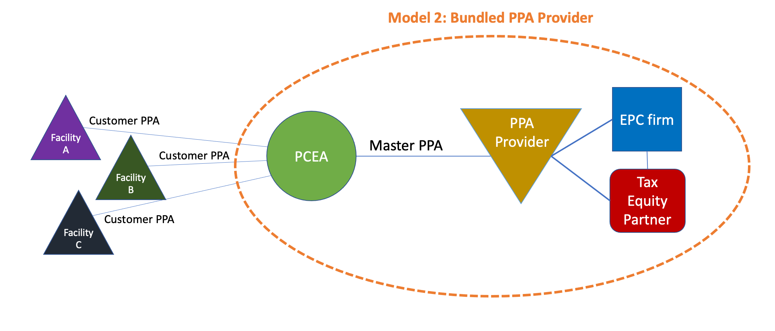

Proposal Options
PCEA is seeking proposals from firms that fall into one or both of the following categories:
- EPC contractors that will procure, install, commission, and maintain the systems for a specified price and do not monetize the tax benefits, which PCEA does independently. (See Model 1 above)
- Bundled Master PPA providers that will procure, install, commission, operate, and maintain the systems (via their own EPC contractor) and can provide Peninsula Clean Energy a 20-year Master PPA with pricing that reflects a share of the tax benefits. (See Model 2 above)

Minimum Proposer Requirements
The following are minimum requirements for all Proposers, inclusive of Proposer’s subcontractors:
- A minimum of 15 fully completed and operational solar installations, of which 5 are commercial installations with a capacity of at least 100kW each
- A minimum of 5 rooftop, 5 carport, and 5 ground mount installations
- A minimum of 5 installations in PG&E territory
- A minimum of 3 fully completed and operational battery energy storage installations of at least 30 kW
For EPC contractors:
- At least 5 years in business as a qualified contractor in California, with a C-10 contractor’s license
- Demonstrable experience successfully applying for and receiving approved commercial interconnections with PG&E
- No outstanding demerits or citations by the California CSLB for any reason for the past 5 years or more
For Master PPA Providers:
- At least 5 years operations in California successfully developing, constructing, financing, and operating solar and solar + storage systems in California
- 10+ years’ experience with commercial scale projects and PPAs, with strong individual executive and project team experience
- Committed and readily available source of all required capital

RFP SCHEDULE
A webinar on this RFP will be held on June 28, 2022. Those wishing to attend can register here. Attendance is encouraged but not required. A recording will be posted to the RFP website.
This is a 2-step RFP. After reviewing these protocols, interested Proposers should submit a brief Statement of Qualifications and Interest that summarizes their qualifications and experience. PCEA will provide Proposers it deems sufficiently qualified additional documentation (“Project Packages”) that includes site-specific design and technical information from which Proposers can further evaluate the proposed sites and systems and submit a proposal. Executing PCEA’s non-disclosure agreement (NDA) will be required to receive this additional information. Instructions on how to submit both a Statement of Qualifications and Interest and a signed NDA are provided in Section 6.1.
We encourage interested Proposers to submit their Statement of Qualifications and Interest as soon as possible and well in advance of the RFP deadline (see schedule below) to ensure you have enough time to review the Project Packages.
The following represents Peninsula Clean Energy's best estimate of schedule at the time of RFP writing and is subject to change, with appropriate notification to Proposers.
 |  | Event | Date
1 | RFP Released  Question and Answer period open. Interested parties may submit questions and Peninsula Clean Energy will post answers publicly on a rolling basis. |  | June 20, 2022
2 | Interested Proposers submit Statement of Qualifications and Interest.  PCEA will provide Proposers it deems sufficiently qualified additional information (Project Packages) for all sites in the portfolio. NDA execution required. Proposals will only be accepted from qualified Proposers. |  | Rolling
3 | RFP Webinar  Registration Link |  | June 28, 2022
4 | Deadline for submitting Statement of Qualifications and Interest  Deadline for Questions |  | July 15, 2022
5 | Deadline for Submitting Proposals |  | August 1, 2022
6 | Notification of Shortlisted Proposers |  | By August 21, 2022
7 | Shortlist Interviews |  | By September 7, 2022
8 | Contract negotiation through execution |  | By November 30, 2022
9 | Project kickoff |  | January 9, 2023

Questions & Answers:
Proposers may submit questions concerning the RFP per the schedule outlined above. Questions and PCEA’s responses will be posted publicly on the RFP website.
Questions should be submitted via email to ProgramSolicitations@PeninsulaCleanEnergy.com
with "[Proposer Name] – Solar RFP Question" in subject line.

DETAILED PROJECT DESCRIPTION AND SCOPE

Pilot Program Overview
This pilot program results from a desire by Peninsula Clean Energy Authority (PCEA) to reduce barriers to solar and solar + storage deployments for local governments in our territory. Local governments often do not have the available staff time, financial resources, or technical expertise to advance these types of projects and may have relatively small facilities with commensurately small projects that cannot take advantage of bulk purchasing. Similarly, solar and storage contractors face high customer acquisition and initial project development costs, which are relatively higher for smaller facilities that cannot support larger solar deployments.
Recognizing these barriers, PCEA has undertaken this pilot program with the following goals:
- To reduce the burden and associated costs for both local governments and solar and energy storage vendors for site identification, evaluation, and design work by PCEA conducting this initial work with the services of an established solar design and engineering firm
- To reduce equipment costs via aggregation of sites into a larger portfolio for higher volume purchasing
- To reduce vendor contracting costs via PCEA serving as a single counterparty for all the customers and sites in the portfolio
- To reduce financing costs by leveraging PCEA’s financial strength and tax-exempt status
- To comply with local government public contracting requirements through this RFP and uniform contractual terms such as prevailing wage
- To reduce project drop-out risk by obtaining formal city council resolutions from portfolio customers of their interest in the projects and pre-authorization for City Managers to execute contracts if PCEA can provide PPA pricing that results in net benefits.
This pilot program, if successful, will become an ongoing program with yearly intake of new facilities for solar and solar + storage deployments.

Pilot Portfolio
PCEA has worked with its city and county partners to identify strong candidate sites for solar and solar + storage systems. PCEA retained McCalmont Engineering of Campbell, CA to conduct site assessments and develop solar and solar + storage designs. McCalmont Engineering was selected via competitive solicitation based on a combination of factors, primary among them expertise in this work.
Note, for the purposes of simplicity, “system” shall be used to denote both solar and solar + storage systems unless further clarity is required.
The following activities have been completed for all sites to date:
- Walkthroughs and reviews of physical sites, including suitability for solar and storage systems, existing electrical configurations and interconnection complexity, structural analysis, and analysis of shading issues
- For sites with proposed solar + storage systems:
  - An analysis of full load versus critical load backup and, if critical loads, a critical load analysis and respective battery sizing
- “60% designs”, which include solar sizing, layout, site plan, and single line diagram. It is expected the selected Proposer will complete the remaining 40% design
- Solar production analyses using PVsyst to provide expected generation potential for each site
- Iteration with customer and approval by facility staff of proposed design
- Bill savings estimate utilizing 2019 (pre-COVID) load data and hourly PVsyst solar production estimate
- Presentation to respective city councils and securing formal resolution from councils authorizing their city managers to move forward with installations if pricing for the solar system received via this RFP enables PCEA to provide financial and/or community benefits. All sites have the engagement and support of their respective city managers.
  - For sites with energy storage, we expect further iteration with customer on system sizing will be required following receipt of pricing, including determination of financial savings/costs with the addition of the energy storage
- Structural assessments by a qualified engineer to confirm suitability of structure to support proposed system
- Confirmation by facility staff of no prohibitive roofing/resurfacing or related issues that would materially impact proposed system
The following are the constituent projects of the Pilot Portfolio. Full Project Packages for each site will be provided to Proposers per the process explained in Section 4.4 below.
PCEA will be contracting with one proposer for the entire portfolio inclusive of all sites below.
Facility Location | Solar Rooftop (kW DC) | Solar Carport (kW DC) | Ground Mount (kW DC) | Estimated Annual Production (MWh/Yr 1) | Battery (kW AC/kWh)
Atherton | 113.5 | 0 |  | 177.6
Belmont | 29.5 | 59 |  | 140.4
Brisbane | 11.1 |  |  | 17.4 | 25 / 155
Colma | 17.2 | 44 |  | 95.2 | 40 / 415
Redwood City | 29.5 | 59 |  | 141.3 | 75 / 300
Hillsborough | 26.6 | 39.4 |  | 100.5
Los Banos |  | 150 |  | 249.1
Los Banos |  |  | 277 | 492.5
Millbrae | 118.5 | 293 |  | 639.5
Millbrae | 155 |  |  | 224.4
Pacifica | 76.7 |  |  | 119.8 | 60 / 240
San Bruno | 271.8 |  |  | 408.2
San Carlos | 29.5 |  |  | 42.7
San Mateo County | 125.5 |  |  | 201.7
San Mateo | 81.2 | 89 |  | 266.5
TOTALS | 1086 | 733 | 277 | 3317 | 205 / 1110
Energy Storage note: Some of these are unusual battery configurations (kW vs kWh). Sizing here was developed to meet customer backup power needs (loads and duration) as defined by customer. Upon receiving pricing, it is likely further iteration will be required with the customer to best balance cost and function.

Pricing and Customer Commitments
PCEA has secured commitments from all site owners in the Portfolio that they will move forward with installation of projects provided that PCEA – once equipment pricing is obtained via this RFP – can provide a PPA that will provide net savings to the customer. As such, pricing will be a key “go/no-go” decision for execution of a contract from this RFP. If no qualified Proposer can provide sufficiently favorable pricing on the portfolio, no Proposer will be selected.

Project Packages
Project Packages will be provided by PCEA to qualified Proposers. These packages contain the following documentation for each site:
- Brief system description
- Site plan with system sizing and layout
- Single line diagram
- Solar production (PVsyst) estimates
- 1 year of 15-minute load data (2019 for most sites to minimize COVID-related, and presumed temporary, building usage changes)
- Structural engineering report
- Notes of any site-specific considerations
Project Packages will be released to Proposers according to the following process:
- Proposers submit a Statement of Qualifications and Interest describing their experience and qualifications
- Proposers are deemed sufficiently qualified and experienced by PCEA to deliver the requested services
- Proposers submit a signed non-disclosure agreement (NDA)
- PCEA provides qualified Proposers access to a cloud folder with Project Packages
A sample Project Package with redacted customer information is available to all Proposers on the RFO website for one site in the portfolio.
Only Proposers who have submitted a Statement of Qualifications and Interest and are deemed qualified will receive Project Packages for all sites and be eligible to participate in the RFP.
See Section 6 below for submittal information.
The Statement of Qualifications and Interest must be submitted by the deadline specified in the RFP SCHEDULE.

Project Development: Risk Mitigation Activities
PCEA and its solar design and engineering services partner, McCalmont Engineering, have done extensive project development work to date and endeavored to de-risk projects by identifying and addressing potential obstacles to deploying the specified systems at each site. The activities we have undertaken to de-risk projects include:
- Screened for facilities that are in good working order, expected to be operational, and without planned major renovations for at least the next 20 years
- Conducted site walkthroughs, inspected electrical rooms, existing equipment and capacities, roofs (if accessible), and evaluated potential solar shading issues
- Developed system designs based on prudent electrical practices, that comply with standard building and fire codes, and have the input and support of facility personnel
- Conducted solar production estimates of proposed designs utilizing PVsyst
- Engaged a structural engineer to evaluate each facility for its capability to support the proposed system’s equipment
- Obtained formal city council resolutions in support of each project
- Engaged with facility staff to understand future planned maintenance that could impact the systems (such as roof resurfacing) and whether this work could be pulled forward in advance of any deployment
However, some work was not done because it was impractical or did not make sense to do until the vendor who would deploy systems was engaged. This includes:
- We did not de-energize facilities and open switchgear
- The structural evaluation did not investigate non-structural items such as, but not limited to, roofing, water-proofing, electrical coordination, fire hazards, egress, etc.
- We did not submit any permit applications
As such, unforeseen obstacles may arise in final project development activities undertaken by the selected Proposer that impact the ability to deploy some systems as currently designed. If this is the case, PCEA will work with the selected Proposer and the Customer to determine mutually agreeable solutions that enable the project(s) to move forward. However, PCEA will retain the right to remove a site from the Portfolio if the obstacles will cause the Project to be uneconomic or we would expect major delays in its completion.

Net Energy Metering (NEM) Changes
As of this writing, the CPUC has proposed but not made final a decision on significant changes to the NEM tariff (NEM Successor Tariff). The systems in the pilot portfolio have been designed with the current (NEM2) tariff rules and associated financials in mind. As such, it is PCEA’s goal that all pilot projects qualify under NEM2.
While our preferred approach would be that the Proposer is responsible for submittal of interconnection applications, our concerns about the possibility of a near-term CPUC NEM successor tariff decision have led us to an intent to submit interconnection applications to PG&E prior to Proposer selection and contracting. This does introduce some risk/complexity in that it is expected that at least some interconnection applications will need to be amended. However, systems have been designed to maximize the amount of solar production available at each site and we expect that any changes will not cause the AC output to exceed that submitted in the interconnection applications.

Pilot Nature / Flexibility and Cooperation
This project is a pilot and, as described above, it is likely that the need for unexpected changes may arise despite every effort made to mitigate them. As such, it is vital that the Proposer understands the pilot nature of this project and can be flexible, creative, and cooperative in its work and approach with PCEA and its customers and partners.

Safety
PCEA expects RFO Participants to recognize safety is of paramount importance. Proposers are required to demonstrate that Projects can be designed, constructed, and operated safely. Submission of safety information is required for consideration of any proposals. During the RFP, PCEA may request Proposers provide additional information to demonstrate the safety of the project. Proposer’s demonstration of safety and the safety of its contractors is a continuous obligation through the term of any Agreement(s) resulting from this RFP.

Scope of Work
Firms will be responsible for the following scope of work:

High-Level Scope
EPC Proposers: Procure, install, and commission the specified solar and solar + storage systems over the course of the PPA contract term (20 years).
Bundled Master PPA Providers: Procure, install, operate, and maintain the specified solar and solar + storage systems over the course of the PPA contract term (20 years).

Scope-Related Tasks
The following are tasks related to the execution of the high-level scope. This is not intended to be a fully exhaustive list of all tasks required.
- Conduct subsequent site evaluations as needed to verify ability to deploy specified System, complete 100% designs, and identify any required upgrades for or obstacles to deployment.
- Complete all required design and technical documentation with relevant stamps from licensed and professionally competent professionals. It is permissible, at Proposer's discretion, to hire McCalmont Engineering to complete documentation/designs and be Engineer of Record.
- Procure all equipment, including solar modules, battery systems, inverters, mounting systems, and all related balance of systems components required to install a safe, complete, and fully Code-compliant System.
- Install, test, and commission all equipment
- Obtain Permission to Operate (PTO) letter from PG&E
- Provide for maintenance of equipment at its proper functioning and manage warranty repairs/replacements as necessary
- Provide for revenue quality meter data of system output for use in customer billing to be delivered to PCEA and/or its designees in a format readily digestible by industry-standard data management applications
- Provide a professional industry-standard monitoring platform for PCEA and end customers to view real-time and historical performance of all systems in the portfolio in a user-friendly manner
- Conduct all work in a safe, professional, and workmanlike manner
- Utilize prevailing wage labor

PROPOSAL ELEMENTS
Proposers must provide an proposal that includes all sites in the Portfolio. The proposal will include the following key parameters. Submission of this information is done via the Proposal Form.

Equipment and Installation Price:
Proposers shall provide per-site pricing for all sites in the Portfolio per the designs and documentation in each site’s respective Project Package. Proposers may submit proposals for either or both of the following options:
- EPC Proposers: Sale of equipment and services, payable per milestones as defined in the Proposal Form EPC Proposer worksheet
- Master PPA Proposers: Power Purchase Agreement for energy produced by the systems, paid monthly at a fixed price per kilowatt hour ($/kWh) for 20 years, with an option to purchase the systems for a fair market price after year 20 as specified in the PPA Proposers worksheet. Other terms and buyout options may be proposed in addition to this at Proposer’s discretion.
PCEA will consider alternate pricing proposals, but pricing for each site as designed must be included. Please note Prevailing Wage requirements below and incorporate these into proposed pricing.
The services contemplated under this procurement include “public works”. For all such work funded by this Agreement, the Contractor is required to comply with state prevailing wage law, Chapter 1 of Part 7 of Division 2 of the Labor Code, commencing with Section 1720 and Title 8, California Code of Regulations, Chapter 8, Subchapter 3, commencing with Section 16000, for any “public works” as that term is defined in the statues, including all applicable flowdown provisions. For purposes of complying with prevailing wage laws, the Contractor must comply with the provisions applicable to an awarding body.

Pricing Qualifications and Dependencies:
Proposers shall describe how pricing would change for the following events:
- One or more projects fall out of portfolio due to:
  - Unforeseen and unmitigable obstacles to project’s financial, technical, or temporal viability
  - Customer(s) failure to execute a PPA with PCEA for reasons beyond PCEA’s control (the resolutions passed by city councils authorize but do not require the city manager to execute a PPA, though all city managers for projects in the Portfolio are supportive of their respective projects)
- Projects are delayed beyond milestone date(s) specified by Proposer for reasons beyond Proposer’s control
- Following its own site evaluation, Proposer believes that substantial redesign of the proposed system is required
This is not meant to be an exhaustive list, and Proposers should provide other additional qualification criteria to pricing if they exist.

Equipment Specifications
Provide basic equipment specifications for primary system components as specified in the Proposal Form.
If Proposer intends to use solar modules manufactured outside the USA, PCEA is also requesting pricing for modules manufactured in the USA. This is specified in the Proposal Form.

Performance Guarantee
An annual performance guarantee must be provided for the solar system, specified as % of PVsyst (or similar industry standard solar production estimation tool) estimate.

Warranty
Provide a description of the manufacturer and workmanship warranties for key system components.

Operations and Maintenance (O&M)
EPC Proposers should provide a price (separate from Equipment and Installation price) for O&M inclusive of all the following. Master PPA Proposers must include this in their PPA price.
- Maintenance:
  - Preventative Maintenance: conducting periodic and manufacturer-recommended maintenance that helps prevent equipment malfunctions and failures
  - Corrective Maintenance: conducting repairs, inclusive of all required scheduling and associated project management, for system components when required.
  - Warranty Management: conducting activities required to maintain equipment warranties and, in the event of equipment failure, managing warranty repair/replacement process
- Operations
  - Performance Monitoring: monitoring all equipment to ensure it is functioning optimally and, if not, completing corrective maintenance
  - Alarm Monitoring: monitoring system for alarms and, if received, commencing corrective maintenance along with notification of PCEA and end customer
  - Energy Production / Billing Data: providing revenue meter-grade energy production data to PCEA for the purposes of billing the end customer. Data must be captured at a minimum of 15-minute intervals and in a readily digestible industry-standard format acceptable to PCEA
  - Real Time and Historical Performance Data Portal: providing access to PCEA and end customers to real time and historical performance data via an intuitive, clear, and user-friendly interface accessible via Internet
Additionally, please provide a quote for the following optional maintenance:
  - Cleaning: conducting annual cleaning of modules

Milestone Pricing
Provide milestone pricing breakdown for the milestones specified in Proposal Form.

Schedule
Provide a projected timetable for achieving specified milestones. Timelines may be stipulated relative to a start date (for example, upon permit issuance by AHJ or upon interconnection approval by PG&E).

Caveats and Assumptions
Proposers should identify any assumptions made or special needs required to execute scope of work and/or caveats on proposals. For example:
- Any external dependencies beyond your control that could impact execution of scope of work and what steps Proposer would take to mitigate risks from these dependencies
- Any caveats related to the designs and information in the Project Packages or additional information required beyond what is in the Project Packages, along with which party would be responsible for providing it
- Any work Proposer requires to be completed that you see as clearly not Proposer’s responsibility
Additionally, PCEA welcomes any suggestions for how we might best work together to achieve project goals to the satisfaction of all parties including the end customers.

EPC / PPA Contracts
Proposers submitting as EPC contractors as defined in Section 2.2 Proposal Options above.
EPC Contractors should provide redlines of PCEA’s EPC contract template. This will be provided with Project Packages to qualified Proposers.
Master PPA Providers should provide a copy of their PPA agreement. PCEA recognizes that the Master PPA must be harmonized with PCEA’s customer PPA. Our intent is to coordinate with a selected Proposer to ensure that certain terms, conditions, and obligations are consistent between the two PPAs.

Safety Information
Proposers must return with their proposal package a completed Safety Questionnaire along with any supporting documentation to substantiate its safety record, planning, and processes.

Workforce Narrative
Peninsula Clean Energy requires all proposers to provide documentation describing efforts towards engaging a skilled and trained workforce and targeted hires. At a minimum, projects must comply with Policy 10, “Peninsula Clean Energy’s Sustainable Workforce Policy”.
Link to Sustainable Workforce Policy
The Workforce Narrative submitted by proposers will be used to evaluate potential workforce impacts of proposed projects with the goal of promoting fair compensation, fair worker treatment, multi-trade collaboration, and support of the existing wage base in local communities where contracted projects will be located.

Ethical Vendor Narrative
Per its Policy No. 9, “Peninsula Clean Energy is committed to the highest standards of responsible behavior and integrity in all of its business relationships. PCEA will consider a company’s business practices, environmental track record, and commitment to sustainability in its procurement decisions.”
Link to Ethical Vendor Standards
The Ethical Vendor Narrative should describe proposer’s business practices, environmental track record, and commitment to sustainability in its procurement decisions.

Supplier Diversity Questionnaire (Optional)
Proposers invited to participate in this RFP will be Peninsula Clean Energy’s are encouraged to submit the optional Supplier Diversity Questionnaire, which can be downloaded at: https://www.peninsulacleanenergy.com/wp-content/uploads/2020/05/Peninsula-Clean-Energy-Supplier-Diversity-Questionnaire.docx.
Your response (or lack thereof) will have no impact on your contract status or eligibility to work with Peninsula Clean Energy in accordance with state law.

SUBMITTAL

Submission Format
All documents should be submitted via email to:
ProgramSolicitations@PeninsulaCleanEnergy.com
Emails should have the Proposer’s name and relevant document noted in the subject line, for example:
“Sunny Solar – Statement of Qualifications and Interest”
“Energized Electric – Proposal Package’

Minimum Qualifications
Interested Proposers should submit a Statement of Qualifications and Interest and signed NDA available on the RFP website. The Statement of Qualifications and Interest requests basic company information and completed project history. PCEA staff will review submissions and release Project Packages, defined below, to those that meet the requirements specified in Section 2.3 Minimum Proposer Requirements.
Only Proposers who have submitted a Statement of Qualifications and Interest and are deemed qualified will receive Project Packages and be eligible to participate in the RFP.
The Statement of Qualifications and Interest must be submitted by July 15, 2022

Acknowledgment of RFP Terms
By participating in Peninsula Clean Energy’s RFP process, a Proposer acknowledges that it has read, understands, and agrees to the terms and conditions set forth in these RFP instructions. Peninsula Clean Energy reserves the right to reject any proposal that does not comply with the requirements identified herein. Furthermore, Peninsula Clean Energy may, in its sole discretion and without notice, modify, suspend, or terminate the RFP without liability to any organization or individual. The RFP does not constitute an offer to buy or create an obligation for Peninsula Clean Energy to enter into an agreement with any party, and Peninsula Clean Energy shall not be bound by the terms of any proposal until Peninsula Clean Energy has entered into a fully executed agreement. Only electronic submittals will be accepted.

Checklist of Submission Materials
The following represents a complete submission package:
- For all Proposers
  - Statement of Interest and Qualifications
- For EPC Proposers (deemed qualified)
  - Proposal Form
  - Safety Questionnaire
  - PCEA’s EPC Contract with Redlines
  - NDA(s)
  - Workforce Narrative
  - Ethical Vendor Narrative
  - Supplier Diversity Questionnaire (optional)
- For Master PPA Proposers (deemed qualified)
  - Proposal Form
  - Safety Questionnaire
  - Proposer’s standard PPA Contract
  - NDA(s)
  - Workforce Narrative
  - Ethical Vendor Narrative
  - Supplier Diversity Questionnaire (optional)

ADDITIONAL REQUIREMENTS

Insurance Requirements
  - Commercial General Liability – for bodily injury, property damage, and personal injury $5,000,000 – each occurrence $5,000,000 – in aggregate
  - Business Automobile Liability – “any auto” (Company Vehicles) – At least $1,000,000
  - Personal Automobile Liability – “any auto” (Personal Vehicles) – At least $500,000
  - Worker’s Compensation and Employer's’ Liability (EPL)– injury or death, each accident, of at least $1,000,000 (EPL not required for Sole Proprietor)
  - Excess Liability. Excess liability insurance in excess of the limits provided for in the above policies except employer’s liability, with a limit of not less than $5,000,000, which insurance shall be in umbrella form, to the extent it is commercially available. Proposer Certifications
By submitting a proposal, each proposer certifies under penalty of perjury that:
  - Its submission is not the result of collusion or any other activity that would tend to directly or indirectly influence the selection process; and
  - Proposer is able or will be able to comply with all requirements of this solicitation at the time of contract award; and
  - Neither proposer, its employees, nor any affiliated firm providing the requested goods and services has prepared plans, specifications, terms or requirements for this solicitation, or has any other actual or potential conflict of interest; and
  - Proposer is aware of the provisions of Section 1090 et seq. and Section 87100 et seq. of the California Government Code relating to conflict of interest of public officers and employees, and is unaware of any financial or economic interest of any County officer or employee relating to this solicitation.

REVIEW AND SELECTION PROCESS
PCEA has established qualifying criteria to propose on this Project, including minimum criteria and experience with similar projects as outlined in Section 2.3 Minimum Proposer Requirements. The most qualified proposals will be evaluated and ranked according to “Best Value” for the PCEA and its customers based upon several substantive variables, including but not limited to: price (inclusive of potential impacts from change orders), vendor experience and qualifications, equipment and warranties, performance guarantee, schedule, local business participation, and overall thoroughness of proposal and responsiveness to this RFP.
Additionally, PCEA reserves the right to conduct independent investigation into each vendor, including contacting other entities for whom the vendor has performed work to research the firm’s quality of work, timeliness of performance, adherence to safety requirements, adherence to predetermined schedule, and maintenance of budget. PCEA may, at its sole discretion, factor the findings into its final selection of a Proposer. Top ranked proposers may be asked to interview with PCEA and interviews will be factored into final rankings. The top ranked Proposer will be offered the opportunity to negotiate a Contract with PCEA based on the contract terms documents provided. If the top ranked Proposer is unable to successfully negotiate a Contract with PCEA, PCEA may enter into negotiations with the second highest ranked Proposer. PCEA intends to award the contract to a single firm; however, PCEA reserves the right to award the contract to more than one firm if this is deemed in the best interest of PCEA and its customers.
Proposals will be evaluated and scored according to the following criteria:
Criterion | How Measured | Percent Weight
Pricing, inclusive of an estimation of potential impact of Change Orders and any other potential cost adders | Pricing as proposed in the Proposal Form combined with caveats/assumptions on pricing, approach to managing and pricing of any required changes to system designs and potential cost adders. | 50%
Experience and Qualifications | Evaluation of proposing firm and individual team members’ experience and qualifications, including track record of successfully completing projects on time and within/under budget, and excellent references from prior customers. | 20%
Contract Terms | Assessment of the impact to PCEA by firm’s proposed terms or changes to PCEA’s proposed contract terms. | 15%
Fit | Qualitative assessment of how well the firm's project team and organizational goals/mission align with PCEA team and goals/mission. This includes degree to which Respondent is likely to be a positive reflection on PCEA with PCEA’s host site customers. | 10%
Creativity and Adaptability | Response demonstrates a creative and proactive approach to meeting project's specific and broad goals. | 5%
 | TOTAL | 100%

AGREEMENT TERMS
Awardees will be required to enter into a contract with Peninsula Clean Energy.
Those proposing as EPC Contractors and who are deemed qualified will receive PCEA’s EPC Contract Template. Modification of the contract terms may be proposed by the Proposer for consideration by Peninsula Clean Energy but are not guaranteed to be accepted. Proposers should provide any modifications as redlines in their proposal submission. (See Section 5.1.10 above)
Those proposing as Master PPA Providers should provide a copy of their PPA agreement for PCEA’s review as part of their proposal submission. (See Section 5.1.10 above)
Contracts will require approval by PCEA’s Board of Directors.

SUPPLIER DIVERSITY
Consistent with its strategic goals, Peninsula Clean Energy has a strong commitment to foster a work environment that espouses sustainable business practices and cultivates a culture of innovation, diversity, transparency, integrity, and commitment to the organization’s mission and the communities it serves. As part of that goal, Peninsula Clean Energy strives to ensure its use of vendors and suppliers who share its commitment to sustainable business and inclusionary practices.
To help ensure an inclusive set of vendors and suppliers, Peninsula Clean Energy’s policy requires it to:
1. Strive to use local businesses and provide fair compensation in the purchase of services
and supplies;
2. Proactively seek services from local businesses and from businesses that have been
Green Business certified and/or are taking steps to protect the environment; and
3. Engage in efforts to reach diverse communities to ensure an inclusive pool of
potential suppliers.
General Order 156 (GO 156) is a California Public Utilities Commission ruling that requires utility entities to procure at least 21.5% of their contracts with majority women-owned, minority-owned, disabled veteran-owned and LGBT-owned business enterprises' (WMDVLGBTBEs) in all categories. Qualified businesses become GO 156 certified through the CPUC and are then added to the GO 156 Clearinghouse database.
The CPUC Clearinghouse can be found here: www.thesupplierclearinghouse.com. While Peninsula Clean Energy is not legally-required to comply with GO 156, Peninsula Clean Energy’s policies and commitment to diversity are consistent with the principles of GO 156, and, therefore, Proposers to this RFP are asked to voluntarily disclose their GO 156 certification status as well as their efforts to work with diverse business enterprises, including those owned or operated by women (WBE), minorities (MBE), disabled veterans (DVBE), and lesbian, gay, bisexual, or transgender people (LGBTBE).
As a public agency and consistent with state law, Peninsula Clean Energy will not use any such provided information in any part of its decision-making or selection process. Rather, Peninsula Clean Energy will use that information solely to help evaluate how well it is conforming to its own policies and goals. Pursuant to California Proposition 209, Peninsula Clean Energy does not give preferential treatment based on race, sex, color, ethnicity, or national origin.

PENINSULA CLEAN ENERGY LEGAL OBLIGATIONS
Peninsula Clean Energy is not obligated to respond to any proposal submitted as part of the RFP. All parties acknowledge that Peninsula Clean Energy is a public agency subject to the requirements of the California Public Records Act, Cal. Gov. Code section 6250 et seq. Peninsula Clean Energy acknowledges that another party may submit information to Peninsula Clean Energy that the other party considers confidential, proprietary, or trade secret information pursuant the Uniform Trade Secrets Act (Cal. Civ. Code section 3426 et seq.), or otherwise protected from disclosure pursuant to an exemption to the California Public Records Act (Government Code sections 6254 and 6255) (“Confidential Information”). Any such other party acknowledges that Peninsula Clean Energy may submit to the other party Confidential Information. Upon request or demand of any third person or entity not a party to this RFP ("Requestor") for production, inspection and/or copying of information designated as Confidential Information by a party disclosing such information (“Disclosing Party”), the party receiving such information (“Receiving Party”), as soon as practical but within three (3) business days of receipt of the request, shall notify the Disclosing Party that such request has been made, by telephone call, letter sent via email and/or by US Mail to the address or email address listed on the cover page of the RFP. The Disclosing Party shall be solely responsible for taking whatever legal steps are necessary to protect information deemed by it to be Confidential Information and to prevent release of information to the Requestor by the Receiving Party. If the Disclosing Party takes no such action, after receiving the foregoing notice from the Receiving Party, the Receiving Party shall be permitted to comply with the Requestor's demand and is not required to defend against it.

GENERAL TERMS AND CONDITIONS
1. Peninsula Clean Energy’s Reserved Rights: Peninsula Clean Energy may, at its sole discretion: withdraw this Request for Proposal at any time, and/or reject any or all materials submitted. Proposers are solely responsible for any costs or expenses incurred in connection with the preparation and submittal of the materials for this RFP.
2. Public Records: All documents submitted in response to this RFP will become the property of Peninsula Clean Energy upon submittal and will be subject to the provisions of the California Public Records Act and any other applicable disclosure laws.
3. No Guarantee of Contract: Peninsula Clean Energy makes no guarantee that a contractor and/ or firm added to the qualified vendor list will result in a contract.
4. Response is Genuine: By submitting a response pursuant to this RFP, Proposer certifies that this submission is genuine, and not sham or collusive, nor made in the interest or on behalf of any person not named therein; the submitting firm has not directly or indirectly induced or solicited any other submitting firm to put in a sham proposal, or any other person, firm or corporation to refrain from submitting a submission, and the submitting firm has not in any manner sought by collusion to secure for themselves an advantage over any other submitting firm.

PCEA must have a buyout option at end of term
Selection from this solicitation does not guarantee selection for future rounds of the program.
The San Bruno facility is provisional pending city council approval, which is expected on 6/28/22. If the project is not approved, Bidders will be notified in advance of the RFP deadline.
Same note as above
The San Mateo County Health Services Administration is governed by the San Mateo County Board of Supervisors, not a city council. We have obtained a formal letter from the Board of Supervisors in support of the project.
All existing facilities were assessed via on-site walkthroughs including review of electrical room layouts, switchgear equipment ratings, and potential for expansion. However, sites were not de-energized to open switchgear, which if required is expected to be conducted by the EPC Contractor prior to completion of design. See Section 4.5.
As each PPA will be specific to each facility in the Portfolio, we need to understand pricing at the site level. Furthermore, in the event an unforeseen obstacle prevents moving forward with a given site, site-level pricing would enable transparent re-estimation of the total contract value.

